June 2026 - Maple Hills PTA Newsletter

One for the Books!
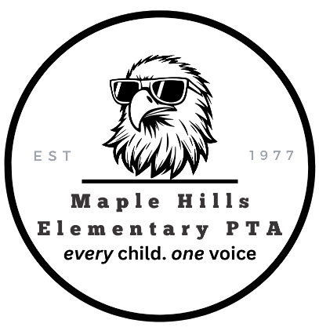
The Chirp!
Message from our incoming PTA President for the 2026-2027 school year.
I’m Kirby White, the incoming PTA President. My family has lived in the Maple Hills neighborhood for four years, and our daughter, Macie, just finished a wonderful kindergarten year with Mrs. Kardong.
Even though we are relatively new to the school, it is clear that this is a special community, and I am excited to be a part of it. I’m looking forward to a great year focused on bringing Maple Hills families together, providing resources to enrich the curriculum and school experience, getting more dads involved, and advocating for more support for our teachers.
Kirby White
(Incoming) Maple Hills PTA President
maplehillsptapresident@gmail.com

Important PTA Event Dates
June 12
Fifth Grade Promotion
June 14
Tacoma Rainiers Baseball Game
June 16
Last Day of school
August 12
Kinder Play Date | 4:00PM Maple Hills Park
August 18
Kinder Play Date | 6:00PM Maple Hills Elementary
As we wrap up another incredible school year, I want to extend my heartfelt thanks to our entire school community. Serving as PTA President for the past two years has been a positive experience I'll never forget. I am continually inspired by the generosity and dedication of our families, staff, teachers, and volunteers. Together, we've built meaningful connections, supported enriching programs, and created memorable experiences for our students.

A personal shout out and thank you to all of our PTA Awards nominees for outstanding volunteerism and advocacy this year: Jessica Webb, Darcie Kardong, Ken Brunell, Yaz Armstrong, Devon Deaton, Alyssa Kawamoto, Anne Krauser, Amber Bryant, Ashley Grassley, Catherine Disney, Lisa Lecoq, George Nowik, Michela Crawford, Jennifer Cook, and Jodi Tutor.

As I step away from this role and welcome a new PTA President and Executive Board, I do so with great confidence and excitement for what lies ahead. Thank you for your partnership, encouragement, and countless contributions over the past two years. It has truly taken a village, and I am grateful to have been part of such a remarkable one. Wishing everyone a wonderful summer and I'll see you around next year!

Heather Stiles
Maple Hills Elementary (Outgoing) PTA President
2026-2027 PTA Elected Board Members
Thank you to everyone who participated in our recent PTA election!
We are excited to announce the elected board for the 2026–2027 school year:
• President: Kirby White
• Vice President: Amanda Heinz
• Secretary (Co): Erica Sweany & Maggie Schulze
• Treasurer: Rhett Hadman
A huge thank you to these individuals for stepping up and accepting their nominations, and to our entire community for your continued support of the PTA.
We would also like to extend our sincere appreciation to our outgoing PTA Board members for their dedication, leadership, and countless volunteer hours in support of Maple Hills Elementary:
• Heather Stiles, President
• Anne Krauser, Vice President
• Stephanie Cryer, Treasurer
• Jorgan Peadon, Secretary
Thank you for your service, commitment, and the positive impact you have made on our students, staff, and families.

Recognition
We would also like to recognize the many volunteers serving as program and event chairs, including Amy St. Pierre (Book Fair), Stacey Field (Field Day), Michelle Peadon (Glow Party), Sarah Ashbaugh & Kelly Brunnell (5th Grade Celebration), Keira Avila (Popcorn Friday and Variety Show), Alexander Sheu (Watch D.O.G.S./Watch M.O.M.S.), Zina Shaughnessy (Pizza Bingo), Jen Cook & Jessica Webb (Yearbook), Natalie Anderson (Eagle Reader Program), all the art docents in class each month, and the dozens of additional volunteers who support our students throughout the year.
Whether you lead a committee, volunteer at an event, help in a classroom, or support behind the scenes, thank you for making Maple Hills such a special community.

Fundraising Update
Our fundraising efforts this year were made possible through the incredible generosity and participation of our Maple Hills community. In an effort to move away from a fundraising auction and meet our annual budget, our goal was to raise $40,000. Through a variety of events and programs, we raised essential funds that helped support student enrichment, family engagement activities, classroom resources, and PTA-sponsored programs throughout the year. These successes would not have been possible without the dedication of our fundraising team. A special thank you to Fundraising Chair Alyssa Kawamoto and Co-Chair Amanda Williams for their leadership, creativity, and countless hours spent planning and coordinating fundraising opportunities that benefited our entire school community.

- Corporate matching - $9,000
- Restaurant Nights - $2,100
- Game Tickets - $2,800
- Adult Bingo Night - $2,600
- Poinsettias and Flower Baskets - $1,500
- Eagle Spirit Wear - $1,000
- Readathon - 18,500
- Pizza Bingo - $1,650
TOTAL…………$39,150
🌸 Kinder Play Dates
Don’t miss out on the upcoming Kinder Play dates!
Follow us on Facebook or subscribe to our regular e-bulletins.

